Lesson 6: Is there also a quantitative relationship between the change in momentum, force, and the amount of time the force acts on an object?

Previous Lesson | We collected data from a simulation and used it to argue for whether the relationships we discovered hold for any other collision conditions. We used alternate algebraic models to solve for the mass or velocity of an object before a collision.
This Lesson  Investigation  3 days   | 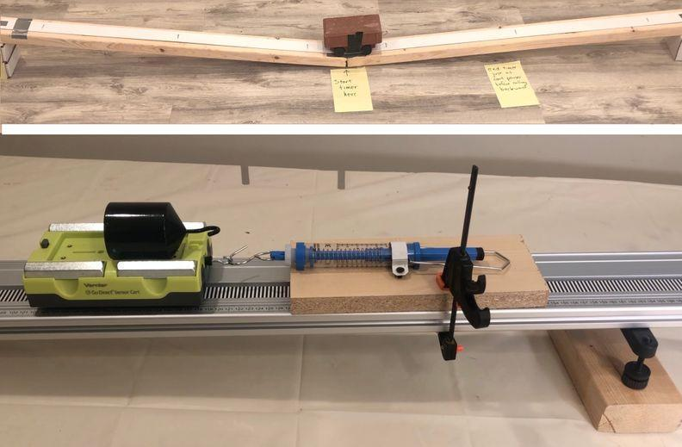 | We use a controlled environment of a cart going down and up a ramp to investigate the relationship between the net force being applied on the cart, and the time over which this force is applied. We use a visual representation to analyze how these two variables interact to cause the changes in momentum we observed. We consider the limitations of our data in light of the difficulty of measuring these variables and use results from a frictionless system to identify the mathematical pattern for the change in momentum. We develop a mathematical model that integrates force, time, and change in momentum.
Next Lesson | We will take an assessment and revisit our DQB. We will compare new datasets to our Lesson 1 trend lines and identify that trends should be going up based upon our data, but are not. We add new questions to the DQB.

BUILDING TOWARD NGSS  HS-ETS1-3, HS-PS2-2, HS-PS2-3, HS-PS2-1   | What students will do  6.A Plan and conduct an investigation collaboratively to produce data to serve as the basis for making a claim about the expected changes in the motion of a macroscopic object when the initial conditions of the net force acting on it, its mass, and change in velocity of an object are defined. (SEP: 3.3, 3.6, 4.1, 6.1 ; CCC: 3.1 ; DCI: PS2.A.1)  6.B Analyze data and use multiple mathematical representations (box-plots, bi-variate graphs, area grids, algebraic symbols and operations, and equations) to identify and describe the quantitative relationship between the change in momentum of an object, the force applied to it, and the length of time over which that force is applied (SEP: 4.1, 5.2; CCC: 3.5 ; DCI: PS2.A.1)  What students will figure out  - It is not possible to eliminate measurement errors, but steps can be taken to reduce them.  - To change the momentum of an object, you need to apply forces on it over a certain amount of time.  - The magnitude of the force acting on an object and the length of time it is applied determines how quickly the momentum of that object changes.  - There is an inverse relationship between the magnitude of the force applied on an object and the time it takes to change its momentum.

Lesson 6 • Learning Plan Snapshot
Part | Duration | Summary | Slide | Materials
1 | 5 min | NAVIGATE  Remind ourselves what we were wondering. | A-B | Relationships between variables for 2 colliding objects poster, Momentum relationships poster.
2 | 8 min | ESTABLISHING OUR EXPERIMENTAL SETUP  Determine a way to investigate the relationship between change in momentum, force, and time. | C-F | Relationships between variables for 2 colliding objects poster, 2 carts, two 4 feet 4”x2” boards, 8 feet vinyl blind, 2 index cards, duct tape
3 | 4 min | PREDICT THE CHANGE IN VELOCITY  Distribute whiteboards to pairs of students. Direct students to use the whiteboard to represent on a graph the change in velocity of a cart going up and down a ramp. | G-H | Momentum Change Investigation, https://www.youtube.com/watch?v=apSzgt3mg7c&list=PLSLDxqPb5NQmc9aOPrh0SjG_BRiZsVdWA&index=8, computer, projector
4 | 6 min | CONSIDER SOURCES OF ERROR  Ask students to measure the time the gravitational force acts on the cart going up the ramp. Discuss as a class sources of error in our measurements and steps that can be taken to collect more accurate data. | F-H | Stopwatches, Computer
5 | 6 min | MEASURE FORCES ACTING ON THE CART  Demonstrate protocol to measure the net force acting on the cart. Ask students to make predictions about the force and time relationship. | L
6 | 16 min | CARRY OUT INVESTIGATION  Assign groups a workstation. Distribute materials to groups, and use the remaining time to conduct this investigation. | M | Momentum Change Investigation, Calibration Protocols, workstation, cart with brick attached, stopwatches, computer

End of day 1
7 | 5 min | NAVIGATE  Turn and talk about the reliability of our data and the advantages of comparing our results as a class. | N
8 | 15 min | INTERPRET RESULTS FROM INVESTIGATIONS  Discuss the main findings from the investigations as a whole class and motivate the need to look at the relationship between momentum change and force over time. | O-Q | Momentum Change Investigation, Relationships between variables for 2 colliding objects poster
9 | 22 min | DEVELOP A MODEL AND USE MATHEMATICAL THINKING  Use a visual representation of the data to help students make sense of the relationship between the change in momentum of the cart and the force acting on it over time. | R-S | Calculator, Blank Grid Models, 1 blue marker, 1 orange colored marker, Relationships between variables for 2 colliding objects poster
10 | 3 min | NAVIGATE  Discuss issues of measurement accuracy and brainstorm ideas to collect more precise data. | T

End of day 2
11 | 4 min | NAVIGATE  Brainstorm as a class ideas to improve the experiment in order to collect more precise measurements of force and time. | U
12 | 5 min | INTRODUCE THE SYSTEM TO ANALYZE ADDITIONAL DATA  Introduce the additional conditions that students will analyze next time in order to continue exploring the relationship between Force and Δt | V-W | Ramp Conditions 1-4
13 | 20 min | REPRESENT THE CHANGE IN MOMENTUM  Instruct students to use the second page of Blank Grid Models to identify mathematical relationships among force, Δt, Δv, and mass. | X-Y | Computer, Blank Grid Models, calculator.
14 | 12 min | USE MATHEMATICAL THINKING  Distribute Blank Grid Models to every pair and ask students to cut the variable cards using scissors. Instruct them to rearrange the variable cards to represent the mathematical relationship that seems to connect these variables. Invite pairs to share. | Z-BB | Blank Grid Models, Variable/Operation Cards scissors, Chart paper for Momentum Change poster, markers
15 | 4 min | NAVIGATE  Elicit student ideas about the factors that we could change as engineers or as drivers to reduce the momentum in a collision | CC-DD

End of day 3

Lesson 6 • Materials List
 | per student | per group | per class
Lesson materials | - Momentum Change Investigation  - Calculator  - Blank Grid Models  - Science notebook  - Ramp Conditions 1-4 | - Momentum Change Investigation  - Calibration Protocols  - workstation  - cart with brick attached  - stopwatches  - computer  - Computer  - Blank Grid Models  - calculator.  - Variable/Operation Cards scissors | - Relationships between variables for 2 colliding objects poster  - Momentum relationships poster.  - 2 carts  - two 4 feet 4”x2” boards  - 8 feet vinyl blind  - 2 index cards  - duct tape  - https://www.youtube.com/watch?v=apSzgt3mg7c&list=PLSLDxqPb5NQmc9aOPrh0SjG_BRiZsVdWA&index=8  - computer  - projector  - Stopwatches  - Computer  - 1 blue marker  - 1 orange colored marker  - Chart paper for Momentum Change poster  - markers

Materials preparation (45 minutes)

Review teacher guide, slides, and teacher references or keys (if applicable).

Make copies of handouts and ensure sufficient copies of student references, readings, and procedures are available.

- Display the Relationships between variables for 2 colliding objects poster.
- Print the Variable and Operation Cards in Variable/Operation Cards. Cut out each rectangle, or provide students with scissors to do it themselves.
- Prepare chart paper for poster

Test the videos students will view:
- https://www.youtube.com/watch?v=XWL4hif9iHI&list=PLSLDxqPb5NQmc9aOPrh0SjG_BRiZsVdWA&index=7
- https://www.youtube.com/watch?v=0WIDhiNP660&list=PLSLDxqPb5NQmc9aOPrh0SjG_BRiZsVdWA&index=6
- https://www.youtube.com/watch?v=DL7ue3bVgDE&list=PLSLDxqPb5NQkfUcmO-T28ZTVBX6CvHskL&index=2
- https://www.youtube.com/watch?v=apSzgt3mg7c&list=PLSLDxqPb5NQmc9aOPrh0SjG_BRiZsVdWA&index=8
Test the website students will use:
- https://codap.concord.org/app/static/dg/en/cert/index.html

Day 1: Cart on ramp investigation
- Group size: 4-5 students
- Setup: Prepare a ramp setup for every group of students using 2 “4 feet wood logs”, 2 2”x4”x6” cardboard boxes, 8 feet vinyl blind, and index cards. Watch https://www.youtube.com/watch?v=DL7ue3bVgDE&list=PLSLDxqPb5NQkfUcmO-T28ZTVBX6CvHskL&index=2 for a short tutorial of how to build the ramp setup with these materials.
For each group, provide 1 cart, 1 brick, 2 or 3 stopwatches, duct tape, markers.
- Safety: Ensure students use safety goggles
- Disposal: None
- Storage: Store materials in a cabinet in the classroom

Lesson 6 • Where We Are Going and NOT Going

Where We Are Going

Day 1 of this lesson is designed to motivate the need to investigate the relationships between mass of an object, its change in velocity, the force acting on it, and the extent of time the force acts on it.
On day 2, the results from this investigation will be used to derive a mathematical relationship that connects these variables.

This lesson is designed to coherently build ideas related to the following disciplinary core idea:
- PS2.A.1: Forces and Motion. Newton’s second law accurately predicts changes in the motion of macroscopic objects. (HS-PS2-1).

Newton’s second law is traditionally represented mathematically like:
F = m * a

During this lesson, students will not refer to the new mathematical relationship as Newton’s second law. Instead, they will use a derived version of this equation that represents directly the relationship between forces over time and changes in momentum:
F * Δt = m * ΔV

This lesson also includes a connections to the Nature of Science, as described in Appendix H of the NGSS: Scientific
Investigations Use a Variety of Methods. Scientific inquiry is characterized by a common set of values that include: logical thinking, precision, open-mindedness, objectivity, skepticism, replicability of results, and honest and ethical reporting of findings.

During the investigation that students will carry out during day 1, they will discuss issues of accuracy and strategies that could be used to obtain more precise data and use CODAP to eliminate outliers.

Where We Are NOT Going

This is not a lesson about acceleration. Although students will be investigating changes of velocity over time, we are not naming this relationship as acceleration yet. In Lesson 8, students will investigate this further.

LEARNING PLAN for LESSON 6
1 · NAVIGATE | 5 min
MATERIALS: Relationships between variables for 2 colliding objects poster, Momentum relationships poster.
Reference the Relationships between variables for 2 colliding objects poster. Present slide A. Give students a half minute to consider the question on their own, then discuss it as a class.

Suggested prompt | Sample student response
Which of these variables have we uncovered a mathematical relationship between?  m Δv F Δt | M and Δv  For two objects in a collision

Reference the momentum relationships poster to emphasize that equations we developed only relate two of these types of variables together (m and delta v), but do suggest any mathematical relationship to the other two (F and delta t).

Consider approaches to use to explore any possible relationships. Present slide B.

Suggested prompt | Sample student response
How can we use what we figured out about change in momentum (mΔV) to make predictions about the connections to other variables we are interested in? | Maybe there is a ratio or area relationship between F and Δt.  Maybe twice as much force takes half as much time to produce the same effect in a system.  We could analyze data on force and Δt next, from sensors or detectors.  We could try to develop equations from our data or test our ideas in a simulation  We could see how much force it takes to change an object's momentum, and how long that force is applied for.

2 · ESTABLISHING OUR EXPERIMENTAL SETUP | 8 min
MATERIALS: Relationships between variables for 2 colliding objects poster, 2 carts, two 4 feet 4”x2” boards, 8 feet vinyl blind, 2 index cards, duct tape
Make sure you have a lab setup at the front of the room where students can all see, or have students gather around one of the lab setups in the room.

Orient students to the carts and tracks. Tell students that we don’t have the fancy frictionless cart setup that we saw in the videos, but that we do have some carts, and some tracks. Demonstrate a collision quickly, and then ask, How would we measure the force from that collision if we don’t have the sensors we saw last class? What about the time over which the force is applied? Look for ideas about spring scales, and stop watches.

Problematize the idea of timing the collision. Say, How could we measure the time that the force is being applied here? Demonstrate the collision again.

If the class does not mention that measuring this is too difficult, provide stopwatches to a handful of students to measure Δt. Ask volunteers to share the time they registered. The goal here is simply to identify that measuring this accurately is too difficult given how short the collision time is for elastic collisions.

Switch from contact forces to gravity to increase Δt. Present slide C, and ask students to consider if there is another force we could be playing around with that could be applied over a longer period of time to make measuring Δt and F more feasible. If students suggest pushing the cart, point out that then it will be impossible to measure the force. Look for ideas about gravity, or letting the cart roll down a ramp. If these ideas do not come up, suggest, What if we just used gravity, which is already acting on the cart. Then point to the bottom of slide C and ask, How could we modify our setup to control how much gravity is being applied to the cart?

Look for ideas about lifting the cart, using a spring scale, etc. Validate all ideas, and remove one of the carts from the setup at the front of the room.

Lift the ramp to create an incline. Lift the launching ramp and hold the cart 1 foot up the ramp but don’t release it. Ask them to pay attention to how fast the cart moves when it reaches the bottom of the ramp.

Consider the shift from contact to distance forces. Show slide D, and give students a moment to turn and talk about the prompt on the slide: Do you believe that momentum for the system will be conserved when the forces are not contact forces? Why or why not?

After a minute, bring students back together and tell them, We aren’t 100% sure if this conservation of momentum thing is true for all forces, or just contact forces. So we cannot assume that the momentum of the system will be the same before and after we let go of the cart. If momentum is being lost from the system though, we want to make sure that the same amount is being lost each time. Since the mass doesn’t change then, we want to make sure the velocity change is always the same.

Explain how to maintain constant change in momentum for each release. Emphasize that a fixed release location on the ramp provides us a way to ensure that equal mass carts will have equal momentum, as long the release height, and ramp angle are the same. Point out the stations around the room that have this ramp setup and suggest that determining whether all of our ramps are using the same release height and mass of cart can help ensure they all are causing the carts at every station to have the same change in momentum by the time they reach the bottom of the ramp. Mention you will provide them with a protocol to make sure the cart is released at the same spot.

Introduce the setup to control the force acting on the cart. Say, In our previous unit, we investigated the forces acting on an object on an incline. and we saw the components of the gravitational force acting on them. If the cart that reaches the bottom of the first ramp then travels up the incline of the second ramp, let’s think about how changing the height of the second ramp would affect the gravitational force acting on it parallel to the ramp.

Draw a force diagram and discuss the forces on the cart. Present slide E. On a new piece of chart paper, or on the whiteboard, develop a diagram showing an object on an incline. Use the prompts on the slide to elicit ideas about the force of gravity parallel to the ramp, and the force of gravity perpendicular. Remind students that these are two components of the same force, and that the force is pointed straight toward the center of the Earth. But because we have placed a ramp in the way, only the component of the vector that is unbalanced will transfer energy, and thus be important for motion. The perpendicular component, on the other hand, is balanced by the push upward from the ramp.

Present slide F and say, Let’s think about the force along the direction of motion. Give students a minute to turn and talk about the question on the slide:
Suggested prompt | Sample student response
What would happen to the magnitude of the unbalanced force component as we increase the angle of the ramp? | The force will increase.

3 · PREDICT THE CHANGE IN VELOCITY | 4 min
MATERIALS: Momentum Change Investigation, https://www.youtube.com/watch?v=apSzgt3mg7c&list=PLSLDxqPb5NQmc9aOPrh0SjG_BRiZsVdWA&index=8, computer, projector
Summarize the purpose of our experimental setup. Say, So if we keep the height of the first ramp the same, we can control for the force of gravity, and make sure that the change of momentum as the cart comes down is consistent across conditions. And then if we change the height of the second ramp we can manipulate the force the cart experiences here.


Graph the changes of velocity of the cart. Present slide G. Distribute Momentum Change Investigation . Ask students, How will the velocity of the cart change as it travels along the second ramp? Ask students to complete part 1 of the handout as they discuss this with a partner.

ASSESSMENT OPPORTUNITY | Students progressively complete parts 1-4 of this handout over day 1 of this lesson and complete part 5 at the start of day 2. The corresponding assessment guidance box for all 5 parts of the handout is located at the end of day 2 in the teacher guide.  While the default guidance is to collect the handout at the end of day 2, you could instead choose to collect the handout on day 1 and provide feedback on parts 1-4 of the handout.

Say, Let’s watch a slow motion video of a cart going up and down a ramp, to find evidence about the changes in velocity the cart experiences. Present slide H and project https://www.youtube.com/watch?v=apSzgt3mg7c&list=PLSLDxqPb5NQmc9aOPrh0SjG_BRiZsVdWA&index=8 to elicit student ideas. Look for students to mention the following ideas
- The cart slows down on the way up
- It speeds up on the way down
- There is a point in time where its motion pauses briefly between the two parts and appears to have a velocity close to zero.

Replay the video if the class seems uncertain about different ideas shared during this discussion.

On the board, sketch a graph to reflect these ideas, either linear or nonlinear, as long as it starts positive, passes through zero, and goes negative.

Split the graph into two chunks and focus on the first part. Emphasize that this graph helps us see that the motion of the car has two distinct time chunks, a positive velocity that gets smaller in magnitude as the cart slows down, and a negative velocity that grows in magnitude (even though it is getting more negative) as the cart speeds up. Say, Let’s focus on the first part, where the velocity changes from when it is fastest at the start of the ramp, to where it reaches zero at the top of the ramp.

Mark that velocity change on the graph and say, The velocity has changed over this period of time, so the momentum of the system has changed as well. How could we measure the amount of time it takes for this amount of momentum change to happen? Students might suggest measuring the time at which the cart first starts going up the ramp, up until the point at which it just reaches the highest point in its travel.

Add a marker at the point at which the cart reaches the highest point on the second ramp, and label it with the inclination used. Say, When the ramp is set at this angle, this is the point at which the velocity reaches zero. We can use this marker to get a more accurate time measurement. This marker will provide additional information about the change in momentum of the cart due to the net force acting on it.

4 · CONSIDER SOURCES OF ERROR | 6 min
MATERIALS: Stopwatches, Computer
Measure the time the gravitational force acts on the cart. Present slide I. Distribute stopwatches to some students and ask them to measure the time. Repeat the demonstration again, indicating students when you are about to release the cart. Have the students report out the collision time.  Record these times on the board and use them to highlight the difficulty of getting the time perfectly. Suggest we would have to watch really carefully for both points in time - and that this a good opportunity for us to see how accurate such a measure would be from one trial to the next, as well as how accurate our own abilities are in taking such measurements  Discuss sources of error and brainstorm ideas to mitigate it. Present slide J. Use the slide prompts to elicit student ideas. ✱  Suggested prompt Sample student response  What are some possible sources of error in our measurements? Some students pressed the start and stop buttons at different times  What could we do to reduce the error in our measurements? Do multiple trials for our experiment Measure the same thing more than once Have more than one person measure the time  If every measurement we collect will have some error, which value(s) should we use? We should use the average value  Which value(s) should we discard? We should discard a value when it is too different from similar measurements  Introduce CODAP. Present slide K. Say, One way to identify values that are too high or too low is by using a data analysis software. Display https://codap.concord.org/app/static/dg/en/cert/index.html and show students how to introduce the times they measure in their investigations. Add the time measurements you recorded on the board in CODAP. Then show them how to identify outliers using the “Box Plot” option. Watch https://www.youtube.com/watch?v=XWL4hif9iHI&list=PLSLDxqPb5NQmc9aOPrh0SjG_BRiZsVdWA&index=7 for a brief tutorial of how to record data and identify outliers using CODAP.  Continue, Let’s use this tool to help identify outliers in the data you collect today, so you can get the most reliable measurement possible. The experiences we gain with CODAP today may give us ideas for how we could reuse it for similar data analysis work in future investigations we design. | ✱ SUPPORTING STUDENTS IN ENGAGING IN PLANNING AND CARRYING OUT INVESTIGATIONS  Error during data collection is a unique opportunity to explore the nature of science. Discuss with students the inherent nature of errors in data collection, and strategies that can be used to reduce the impact of error in our results and conclusions.

5 · MEASURE FORCES ACTING ON THE CART | 6 min
MATERIALS: None
Measure the push and pull forces on the ramp at a small inclination. Place a cart in the middle of the second ramp. Use the push bar of the spring scale to hold the cart in the same position. Move the cart upwards very slightly (less than half an inch), and let it fall back on the spring scale. Read out loud the force measurement indicated by the spring scale. Repeat this step a few more times, to point out variation in results. Establish this procedure as the protocol to ensure the spring isn’t getting stuck and giving inaccurate readings.

ADDITIONAL GUIDANCE | Add graphite powder or bearing oil to the plastic sections of the spring scale that move up and down. This will decrease the friction force that causes the spring scale to get stuck. Doing this will help students get more accurate measurements.

Measure the push and pull forces on the ramp at a higher inclination. Measure the force on the cart a second time using the spring scale hook. Push the cart upwards very slightly (less than half an inch), and let it move downwards away from the spring scale. Repeat this step a few more times, and compare these values to the force measurements you obtained with the push method to point out variation in results. Establish this second procedure as the protocol to ensure the spring isn’t getting stuck and giving inaccurate readings. Suggest that we average the force readings from both methods, and use this value for our calculations.

Say, We will consider that this average force would be applied parallel to the ramp for the entire time the cart is on the ramp.

Make predictions about the force and time relationship. Present slide L. Say, We said before that the magnitude of the unbalanced force component will increase if we increase the angle of the ramp. On the board, sketch a force vs. time graph (force is negative).
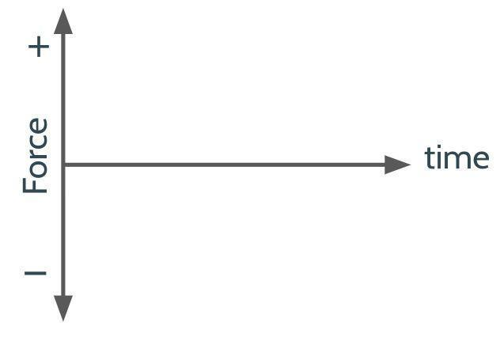
Use it to show the force acting on the cart would be constant over time. Show a second line on the same axis that represents a higher force for an increased angle (a second constant line in a different color).

Distribute Momentum Change Investigation and ask students to write their predictions to the question on the slide:
- How would doubling the amount of force on the cart affect the time it takes to reach a velocity of zero going up the second ramp?

After a minute, invite them to share their predictions.

6 · CARRY OUT INVESTIGATION | 16 min
MATERIALS: Momentum Change Investigation, Calibration Protocols, workstation, cart with brick attached, stopwatches, computer
Distribute experimental and calibration procedures. Present slide M. Say, Let’s investigate our predictions. Distribute materials to each group, and a copy of Calibration Protocols. This document will provide students a list of calibration protocols intended to obtain more reliable data.

Distribute a copy of Momentum Change Investigation to every student, as you might want to encourage every person to collect the data obtained in the groups they work with. Orient them to Part 2 of the handout, and ask them to record their data in the table. Share the link for accessing CODAP https://codap.concord.org/app/static/dg/en/cert/index.html in order to analyze the data and identify outliers.

Carry out an investigation. Refer to the materials preparation section for instructions on how to set a workstation. Distribute materials to groups, and use the remaining time to conduct this investigation. Support groups as they record their data, making sure they are collecting multiple Δt per trial. Help those groups that are having difficulties introducing their results in CODAP.

Once students have decided they have collected enough data, ask them how they have reached this decision. Look for groups to mention that they conducted as many trials as they could to reduce the variability in their results.
ADDITIONAL GUIDANCE | This investigation will provide you an opportunity to see if the expected trends hold. And in the case of any class where they don’t, you will want to provide those groups in those classes, at least one additional set of data from another class to compare to on the next day that better matches the anticipated trend. This may also end up raising a request from those groups to see all other classes to see how that data compares. You may want to allocate 5 extra minutes the next day to look at the data across classes in small groups or together to isolate trends vs. outliers.

End of day 1
7 · NAVIGATE | 5 min
MATERIALS: None
Remind the class where we left last time. Present slide N. Say, Last class we all conducted the same investigation where we released a cart down a ramp and used a second ramp to change the force acting on the cart. We measured the time it would take the cart to go up that second ramp. Use the slide prompts to elicit student ideas about the reliability of their results first as a turn and talk, then as a class.
Suggested prompt | Sample student response
How certain are you of your group’s individual results? | Accept all responses
Should we expect other groups to have the same results from the same conditions? | No, but somewhat similar
What might merging the data from all the groups together help us see? | How much more variation there is among the different groups  We can see if our results are consistent  If we all measured similar times, then we can be more confident about our results

8 · INTERPRET RESULTS FROM INVESTIGATIONS | 15 min
MATERIALS: Momentum Change Investigation, Relationships between variables for 2 colliding objects poster
Interpret results as a whole class. Instruct students to sit with their group from last class and to bring Momentum Change Investigation, where they collected the data from last class. Present slide O and sketch three tables on the board like the one below, one for each ramp height tested. Invite groups to write down their results in each table.

Ramp height:
Group | Lowest Δt measured | Highest Δt measured | Δt Median | Average Force measured

Present slide P. Ask groups to use the results shown on the tables to determine whether each data set has a relatively small spread and the median is similar, or whether they want to use CODAP to remove any potential outliers first. After a couple of minutes, invite groups to share their ideas with the class. If the class decides to remove potential outliers using CODAP for one or all the ramp height conditions tested, assign three groups to collect the results each group measured for one of the ramp heights and introduce them in CODAP. Then invite these three groups to share their findings. Write a summary of Δt and force from the class results.

 | Δt | Force
3.5 inches ramp
4.5 inches ramp
5.5 inches ramp
7 inches ramp

Present slide Q. Ask students to return to their original seats and work with a partner in order to work on the slide prompts:
- Compare the quantitative predictions you recorded earlier for this question: How would doubling the amount of force on the cart affect the time it takes to reach a velocity of zero going up the second ramp?
- Did our class results support or refute your prediction?

Invite students to share their conclusions. Look for some groups to suggest that the results supported their predictions.

9 · DEVELOP A MODEL AND USE MATHEMATICAL THINKING | 22 min
MATERIALS: Calculator, Blank Grid Models, 1 blue marker, 1 orange colored marker, Relationships between variables for 2 colliding objects poster
Motivate the need to further explore the mathematical relationship. Present slide R. Say, Our predictions seem to suggest that many of us think there is a mathematical relationship between force and Δt. Last time we used a grid representation to investigate the relationship between mass and velocity. Let’s use a similar representation to further explore the relationship between time and force.

Represent the change in momentum. Present slide S. Distribute Blank Grid Models to every student. To model how to use the grid representation, use the mean Δt and force values from the lowest height condition that was investigated

Ask students to look at the results from the lowest ramp height written on the board, and restate the Δt value we have found for this condition.  On the board, sketch a force vs. time graph, like the one shown on Blank Grid Models. Draw a blue line along the x-axis up to the position that corresponds to the Δt recorded by the class. The example on the right corresponds to a Δt of 1.48 s.  Then ask students to restate what the force acting on the cart during this test was. Say, Was this net force acting on the cart positive or negative? How do we know? Look for students to say that the net force is negative because it was against the direction of the motion of the cart.  Draw a blue line along the y-axis up to the force value recorded by the class. The example on the right corresponds to a force of -1.1 N.  Complete the corresponding rectangular area using the lines you drew.  Then say, Last time we also calculated the area, and it helped us identify the relationship between the change in momentum of two colliding vehicles.  Instruct students to calculate the area in the space designated in their handouts. |  | 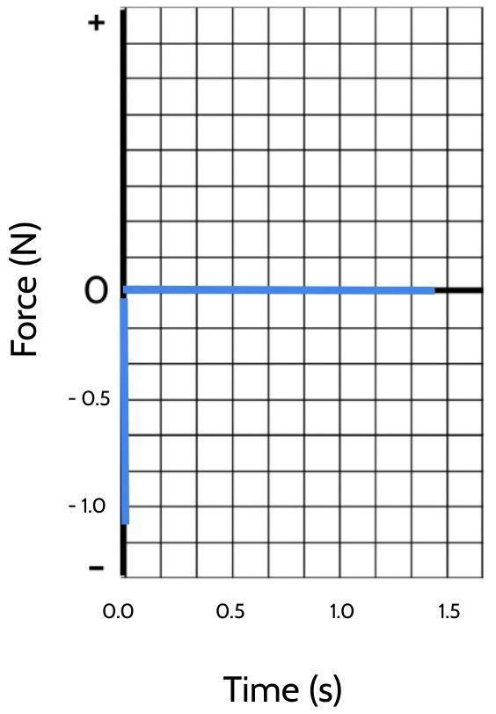  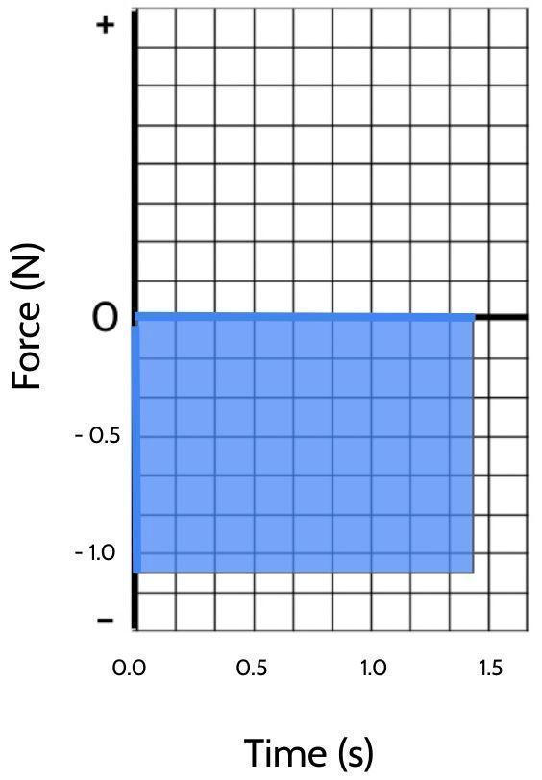


Represent additional force-time relationships. Ask students to develop the grid models and calculate the corresponding areas using the results from the additional ramp heights investigated. Give them 5 minutes to complete this task

ASSESSMENT OPPORTUNITY | What look/listen for in the moment: Students constructing area models for force and Δt for all conditions tested by the class and comparing the areas of each of the rectangles formed (force * Δt) (SEP: 5.2; DCI: PS2.A.1)  What to do: Walk around the classroom making sure students are using the class values for Δt and force to construct their graphs. Once they calculate the areas for each condition, suggest them to compare these numbers.  Building Toward 6.B.1 Analyze data and use multiple mathematical representations (box-plots, bi-variate graphs, area grids, algebraic symbols and operations, and equations) to identify and describe the quantitative relationship between the change in momentum of an object, the force applied to it, and the length of time over which that force is applied. (SEP: 4.1, 5.2; CCC: 3.5 ; DCI: PS2.A.1)

Make sense of the grid representation. Say, We started this investigation because we wanted to explore the relationships between change in momentum, the force acting on an object, and the time this force was applied.
Suggested prompt | Sample student response
What do we know about the momentum of the cart for the three ramp heights we investigated? | We don’t know the velocity or the mass, so we should measure them to know.  Yes, but it should be the same or very similar because the carts had the same mass and velocity.
What do we know about the momentum of the cart when it reaches the highest point on the second ramp? | It is zero  The velocity of the cart is zero, so it has no momentum
And did the point where the cart came to a full stop happen in the same location on the second ramp? | No, the higher the ramp, the lower this point  Yes, the cart would stop faster
So the cart has the same momentum when it reaches the second ramp, and in all three cases, the momentum of the cart changed to zero. But this change happened sooner in some cases, so the way the momentum changed was different. What caused this change in momentum? | The ramp  The force acting on the cart  The higher the second ramp, the sooner the cart reached the highest point on the ramp
Based on our grid models for force and Δt, is there a mathematical relationship (or approximate one) between force and Δt that can help us explain how we can change the same momentum in different ways? | Accept all responses

Say, The momentum of the cart was the same for all three conditions, and in all three conditions it changed to zero, but this change happened sooner when the force was higher. This seems very productive, but we are still unsure about the nature of the mathematical relationship between force and time in all three cases.

10 · NAVIGATE | 3 min
MATERIALS: Science notebook
Discuss issues of accuracy of data. Present slide T. Say, Sometimes, when the data doesn't show a clear pattern, scientists need to decide (1) whether they still have some gaps in their understanding of the phenomenon, (2) whether the current model they have is limited and does not help them make sense of the data, or whether there are reasons to believe that the data that was collected lacked some accuracy due to the difficulty of measuring the variables of interest. ✱  Use the slide prompts to elicit student ideas about issues of accuracy and brainstorm strategies to collect more reliable measurements.  - What were the biggest challenges measuring the time and force with more precision?  - If we could repeat this experiment, what could we do to obtain more reliable measurements of time and force? Accept all responses.    Collect handout for feedback. Collect Momentum Change Investigation to provide feedback on this assessment opportunity.  ASSESSMENT OPPORTUNITY What look/listen for in the moment: Collect students’ copy of Momentum Change Investigation at the end of day 2. Look for students to: al:PM.L5.HO2] at the end of day 2. Look for students to: - Part 1: Sketch a predictive graph of the carts’ velocity vs. time as it travels up and down the ramp and use it to compare what it shows to the changes in the motion of the cart observed from a slow motion video. (SEP: 3.6, CCC:3.1) - Part 2: Make a claim about the predicted quantitative relationship between the magnitude of the net force acting on the cart and the time this force is applied (SEP: 6.1, CCC:3.1, DCI: PS2.A.1) - Part 3: Determine how much data to collect (number of trials and conditions) based on the accuracy and precision of the time and force recorded (SEP: 3.3, DCI: PS2.A.1) - Part 4: Analyze data collected using CODAP, in order to compare variability and central central tendency in two sets of data from different groups. (SEP: 4.1) - Part 5: Use the analysis of the data to make a claim about the quantitative relationship between the independent and dependent variables for the research question investigated (SEP: 6.1, CCC:3.1, DCI: PS2.A.1) What to do: Encourage students to follow the calibration protocols throughout the investigation in order to obtain more accurate measurements. The use of CODAP will support their thinking about variation in their data, so help them input their data in this platform. Regardless of the accuracy of the measurements collected by the class, discuss issues of reliability at the beginning of day 2. Building Toward 6.A Plan and conduct an investigation collaboratively to produce data to serve as the basis for making a claim about the expected changes in the motion of a macroscopic object when the initial conditions of the net force acting on it, its mass, and change in velocity of an object are defined. (SEP: 3.3, 3.6, 6.1 ; CCC: 3.1 ; DCI: PS2.A.1) | ✱ SUPPORTING STUDENTS IN ENGAGING IN PLANNING AND CARRYING OUT INVESTIGATIONS  It is possible that the results obtained by the class do not yield the accuracy necessary to identify any clear pattern in the relationship between force and time for all three cases. Regardless of how close or different are the values obtained by the different groups, discuss the challenges of measuring the time and forces, and how this could have affected the accuracy of the results and thus, the conclusions that can be drawn from them. The goal of this discussion is to recognize the importance of keeping sources of error in mind when conducting an investigation and measuring variables.

End of day 2

11 · NAVIGATE | 4 min
MATERIALS: Science notebook
Brainstorm ideas for collecting more precise data. Present slide U. Instruct students to use the ideas they recorded in their science notebook. Use the slide prompt to elicit student ideas:
Suggested prompt | Sample student response
If we could repeat the experiment we conducted last time, what could we do to obtain more reliable measurements of time and force? | Using better tools, like a camera to record the cart and see it more slowly to measure better the time.  Using digital instruments that could measure force more accurately  Using even lower forces so the time the cart reaches the highest point on the second ramp is longer and thus, easier to measure

12 · INTRODUCE THE SYSTEM TO ANALYZE ADDITIONAL DATA | 5 min
MATERIALS: Ramp Conditions 1-4
Orient students to the system used to collect additional data. Present slide V and say, We are going to extract data from four additional conditions investigated using carts that have more sensitive sensors, so they can collect more precise data to explore this relationship more closely. Describe the four conditions presented in the slide, mentioning that in all four conditions, the cart was launched from the same starting point. Reproduce https://www.youtube.com/watch?v=0WIDhiNP660&list=PLSLDxqPb5NQmc9aOPrh0SjG_BRiZsVdWA&index=6 to give students an idea of how the tests were carried out.

Condition 1 | Condition 2 | Condition 3 | Condition 4
Cart mass = 1.8 kg | Cart mass = 2.3 kg | Cart mass = 2.3 kg | Cart mass = 1.8 kg
1 block ramp incline | 1 block ramp incline | 2 block ramp incline | 2 block ramp incline

Say, Let’s divide up into different groups, each exploring a couple of conditions.


Describe data collection task. Present slide W. Distribute Ramp Conditions 1-4. Ask students to collect their data in their notebooks or on the handout. You can instruct students to complete this task on their own, or to work with a partner, each analyzing a different video.

Cue students to annotate the following pieces of information they will need to extract from the videos they will watch for each condition:
- The mass of the cart (m)
- Velocity of the cart at one point in time.
- Velocity of the cart cart at another point in time.
- The change in velocity (Δv) between these 2 points
- The difference in time (Δt) between these two points.
- The average gravitational force (F) acting on the cart parallel to the ramp over this time.

ASSESSMENT OPPORTUNITY | What look/listen for in the moment: Students identify values of these variables by analyze bi-variate graphs: the average gravitational force (F) acting on the cart in a graph with fluctuations and the change in velocity (Δv) and difference in time (Δt) between 2 self selected points from a linear graph. (SEP: 4.1)  What to do: If students are unsure what data they need to gather from the video, point to slide W. Encourage them to be as accurate as possible when collecting the data from the videos as this will produce momentum change results that are more close. If some students finish this part faster than others, provide them with a third collision scenario video.  Building Toward 6.B.2 Analyze data and use multiple mathematical representations (box-plots, bi-variate graphs, area grids, algebraic symbols and operations, and equations) to identify and describe the quantitative relationship between the change in momentum of an object, the force applied to it, and the length of time over which that force is applied. (SEP: 4.1, 5.2; CCC: 3.5 ; DCI: PS2.A.1)

13 · REPRESENT THE CHANGE IN MOMENTUM | 20 min
MATERIALS: Computer, Blank Grid Models, calculator.
Use grid representation to identify mathematical relationships among variables. Present slide X. Say, Last time we developed a mathematical model, shifting the type of representation we used seemed helpful. Let’s reuse those grids again to see if they can help us make progress on our question about whether there is a mathematical relationship between the four different variables you identified for each condition.


Instruct students to use the second page of Blank Grid Models for this task. They might want to use a calculator to find the value of the areas.

ASSESSMENT OPPORTUNITY | What look/listen for in the moment: Students creating corresponding area grids for force, Δt and for mass, Δv and comparing the relationship between momentum change (m*Δv) and (force * Δt) (SEP: 5.2, 5.3 ; CCC: 3.5 ; DCI: PS2.A.1). Look at Calculation Answers for the approximate values the class should identify.  What to do: If students are unsure what data they need to graph, ask them to circle the values for mass and Δv from their first condition and make an area model for those first. Then ask them to underline the value for average Force and Δt next and make a separate area model for those next. After they do this, ask them to describe how those areas compare.  Building Toward 6.B.3 Analyze data and use multiple mathematical representations (box-plots, bi-variate graphs, area grids, algebraic symbols and operations, and equations) to identify and describe the quantitative relationship between the change in momentum of an object, the force applied to it, and the length of time over which that force is applied. (SEP: 4.1, 5.2; CCC: 3.5 ; DCI: PS2.A.1)

Discuss patterns among the areas. Present slide Y. Use the slide prompt to elicit student ideas:
- Was there a mathematical relationship (or approximate one) between m, Δv, F and Δt for none, some, or all of the four conditions?

Check with each group until you establish that there appears to be equivalent areas on the two grids for every condition (all four) tested.

14 · USE MATHEMATICAL THINKING | 12 min
MATERIALS: Blank Grid Models, Variable/Operation Cards scissors, Chart paper for Momentum Change poster, markers

Construct a mathematical model. Present slide Z. Say, The new data graphed on these grids has helped us identify a very close relationship among these variables. Let’s see if we can identify a mathematical relationship that can help us explain a wide range of collisions. Distribute Variable/Operation Cards and scissors to each pair of students. Suggest that we try rearranging the variable cards to represent the mathematical relationship that seems to connect these variables.

Round Robin Share out. Give students a few minutes to work with rearranging the cards with a partner. After this time, ask them to share their answers. Invite a group of volunteers to share. Write the equation they suggest on the board, and ask the rest of the class:
- Did any other group find the same relationship?
- Who found a different mathematical relationship?

Repeat this process until all groups have shared their answers. Look for the class to build the equation shown below. It is okay if students propose this equation in a different arrangement. Record these variations in the variable arrangements on the board.

ASSESSMENT OPPORTUNITY | What to look/listen for in the moment:  - Students combining the variables and operations to reflect the relationship in the area models (or data) and use words to describe the quantitative relationship between the change in momentum of an object, the force applied to it, and the length of time over which that force is applied. (SEP: 5.2, 5.3 ; CCC: 3.5 ; DCI: PS2.A.1)  Building towards 6.B.4 Analyze data and use multiple mathematical representations (box-plots, bi-variate graphs, area grids, algebraic symbols and operations, and equations) to identify and describe the quantitative relationship between the change in momentum of an object, the force applied to it, and the length of time over which that force is applied (SEP: 4.1, 5.2; CCC: 3.5 ; DCI: PS2.A.1)

Describe the meaning of the new mathematical relationship. Present slide AA. Use the first prompt to invite students to describe in their own words what each side of the equation says.
Suggested prompt | Sample student response
(How) can we describe in words what our proposed mathematical model means? | A force applied on an object over time can cause changes in its momentum  To change the momentum of an object, you need to apply forces on it over certain amount of time  The same amount of force over time, will produce the same amount of momentum change.  A certain amount of force over time, will produce a certain amount of momentum change.  A certain amount of momentum change will require a certain amount of force over time.

Synthesize these ideas on chart paper and title it “Momentum Change”. You will continue using this poster in future lessons to guide discussions, elicit student ideas, and scaffold sense making.

MOMENTUM CHANGE

Forces acting over time on an object cause changes in the momentum of the object

F * Δt m * Δv

This holds for when using metric measurements:
(F in Newtons, Δt in seconds, m in kg, and v in m/s).

ADDITIONAL GUIDANCE | Notice that this is a derived equation from Newton's Second Law. We have intentionally avoided introducing acceleration during this lesson, as this idea will be developed during Lesson 8.

Present slide BB. Say, Now we have two different models to make sense of the change in momentum that objects experience, let’s see which model best helps us predict the outcome of the following collisions. Ask students to use their notebooks to write their ideas. Invite them to use the grid models from Blank Grid Models if they feel stuck.

Suggested prompt | Sample student response
Scenario A: A car of 3,000 kg traveling at a speed of 20 m/s collides inelastically with a car of 1,500 kg traveling at the same speed but in the opposite direction. | 2mv - mv = mv because there are two objects in a collision and both become one system as it is an inelastic collision
Scenario B: A car of 3,000 kg traveling at a speed of 20 m/s collides with a large concrete wall. | m*Δv = F*Δt because there is one cart and we can use this model to explain the force *time relationship

15 · NAVIGATE | 4 min
MATERIALS: Science notebook
Motivate the need to investigate factors that reduce momentum. Present slide CC. Use the slide prompts to elicit student ideas. Ask them to write their answers in their science notebooks.
- Would you rather be hit by a slow car with a low mass (low momentum) or a fast car with a high mass (high momentum)?
Look for ideas about how if we have less change in momentum, we have less force. Point back to the equation we developed relating momentum and force if students need scaffolding here.

When students suggest that less change in momentum means less force, ask, Why is less force a good thing?

Guide students to suggest that we think that the force is what determines the risk to the car and person in it.

Present slide DD. Say, We want to reduce the change in momentum in a collision for each vehicle. Because that will reduce the force. What determines how much momentum can change for a vehicle in a collision?
Look for ideas about starting masses and velocities at the moment of collision.

Say, The momentum of vehicle A is going to determine the change of momentum of vehicle B and vice-versa. So we want to reduce the initial momentum of both vehicles. Let’s take a moment to reflect on these factors and their connections to the outcomes of vehicles in a collision.

Present slide EE. Give students a moment to consider the following questions. Ask students to record their thinking in their notebooks.
- How does our mathematical model help us inform our thinking about:
- The factors we could change (as drivers) to safely reduce our initial momentum in a collision?
- Additional factors we could change as engineers or as a society to try to reduce the momentum of vehicles involved in collisions?

